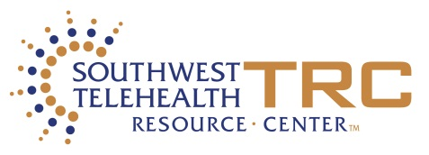

Improving Access to Quality Medical Care

The practice and delivery of healthcare is changing, with an emphasis on improving quality, safety, efficiency, and access to care. Telemedicine can help you achieve these goals!
The Health Resources & Services Administration and the Southwest Telehealth Resource Center invite you to a free webinar on the implementation and practice of telemedicine.
“Telemedicine 101 for Tribal Organizations”
May 22, 2018
11:00 – 12:00pm PDT
This is an opportunity for tribal organizations to learn:
- What is telemedicine?
- What are the benefits to tribal healthcare practitioners & patients?
- What resources are available to those who want to get involved?
The Director of the SWTRC is Elizabeth Krupinski, PhD who has been the Associate Director of Evaluation for the Arizona Telemedicine Program since its inception. She has significant experience with the SWTRC Training Course, teaches statistics, created (as the President) the American Telemedicine Association’s (ATA) Training Accreditation Program, chairs the ATA’s Standards & Guidelines Committee, and has published extensively on a variety of telemedicine topics. She oversees the SWTRC, guides development of the programs offered, tools to be developed, and is responsible for collecting and analyzing all data associated with the evaluation of the SWTRC and its performance.

Elizabeth Krupinski, PhD PhD

Register at https://aztelemedicine.zoom.us/webinar/register/WN_Ckp1a7IcTKCIqjsF3QM_OQ

For more information contact Kristine Erps: kerps@telemedicine.arizona.edu • 520.626.2493

This webinar is made possible through funding provided by Health Resources and Services Administration, Office for the Advancement of Telehealth (G22RH24749). This information or content and conclusions are those of the author and should not be construed as the official position or policy of, nor should any endorsements be inferred by HRSA, DHHS or the U.S. Government.
For questions about disability-related accommodations for this webinar, please visit http://telemedicine.arizona.edu/contact

